Daily Task on S3

1. Create an S3 bucket and upload some objects to S3.

- Login to aws console using root account.
- Navigate to S3 service.
- Select General Purpose Buckets
- Click on create bucket.
- Give bucket Name.
- Click on create bucket.
- Notice that the bucket is created.
- Click on upload button.
- Click on add file or drag and drop a file to be uploaded.
- Observe that the file is displayed in the list.
- Click on upload button.
- Notice that the file is successfully uploaded.
- Click on close button.
- Observe that the uploaded file is displayed.

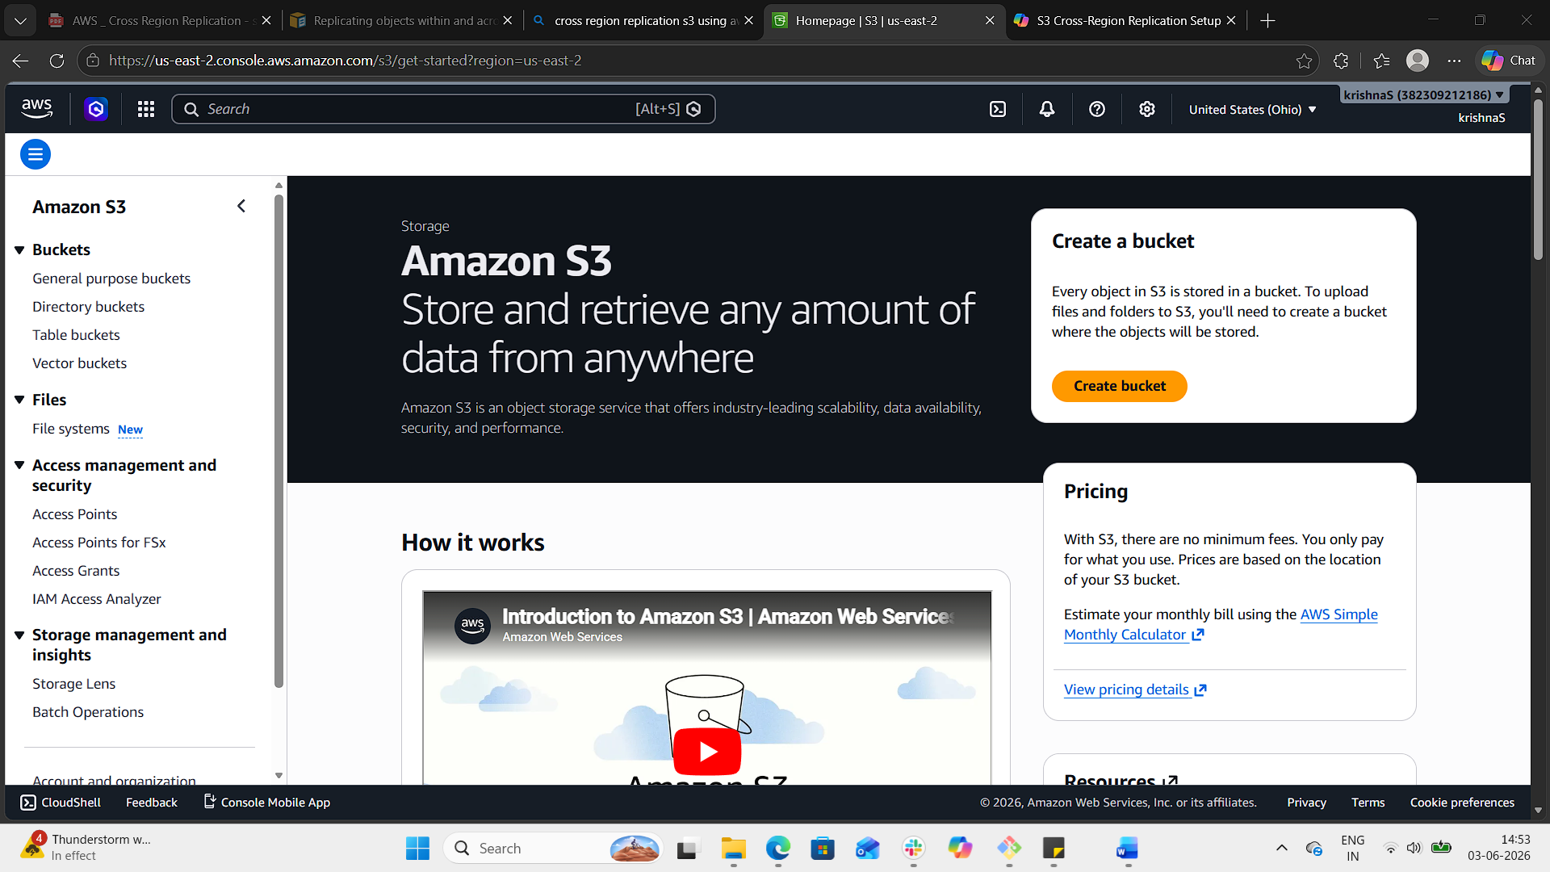

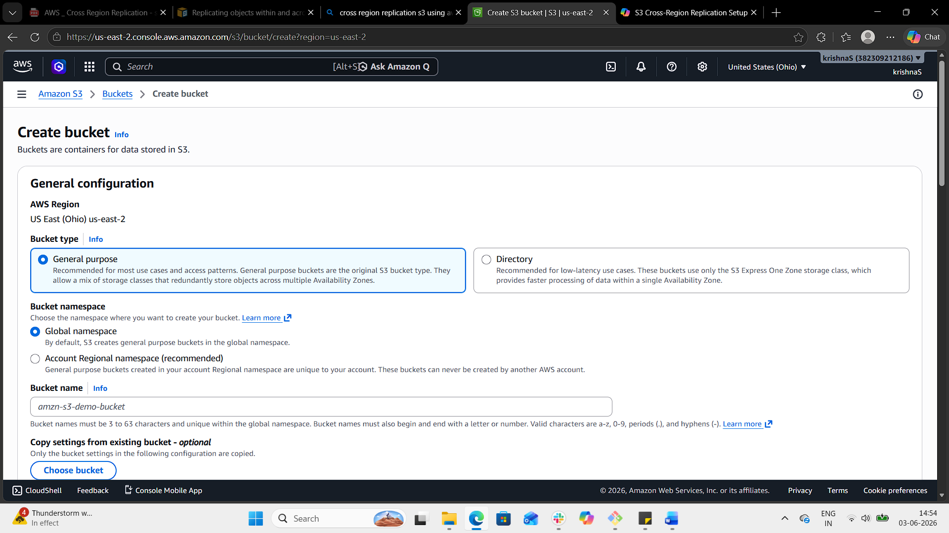

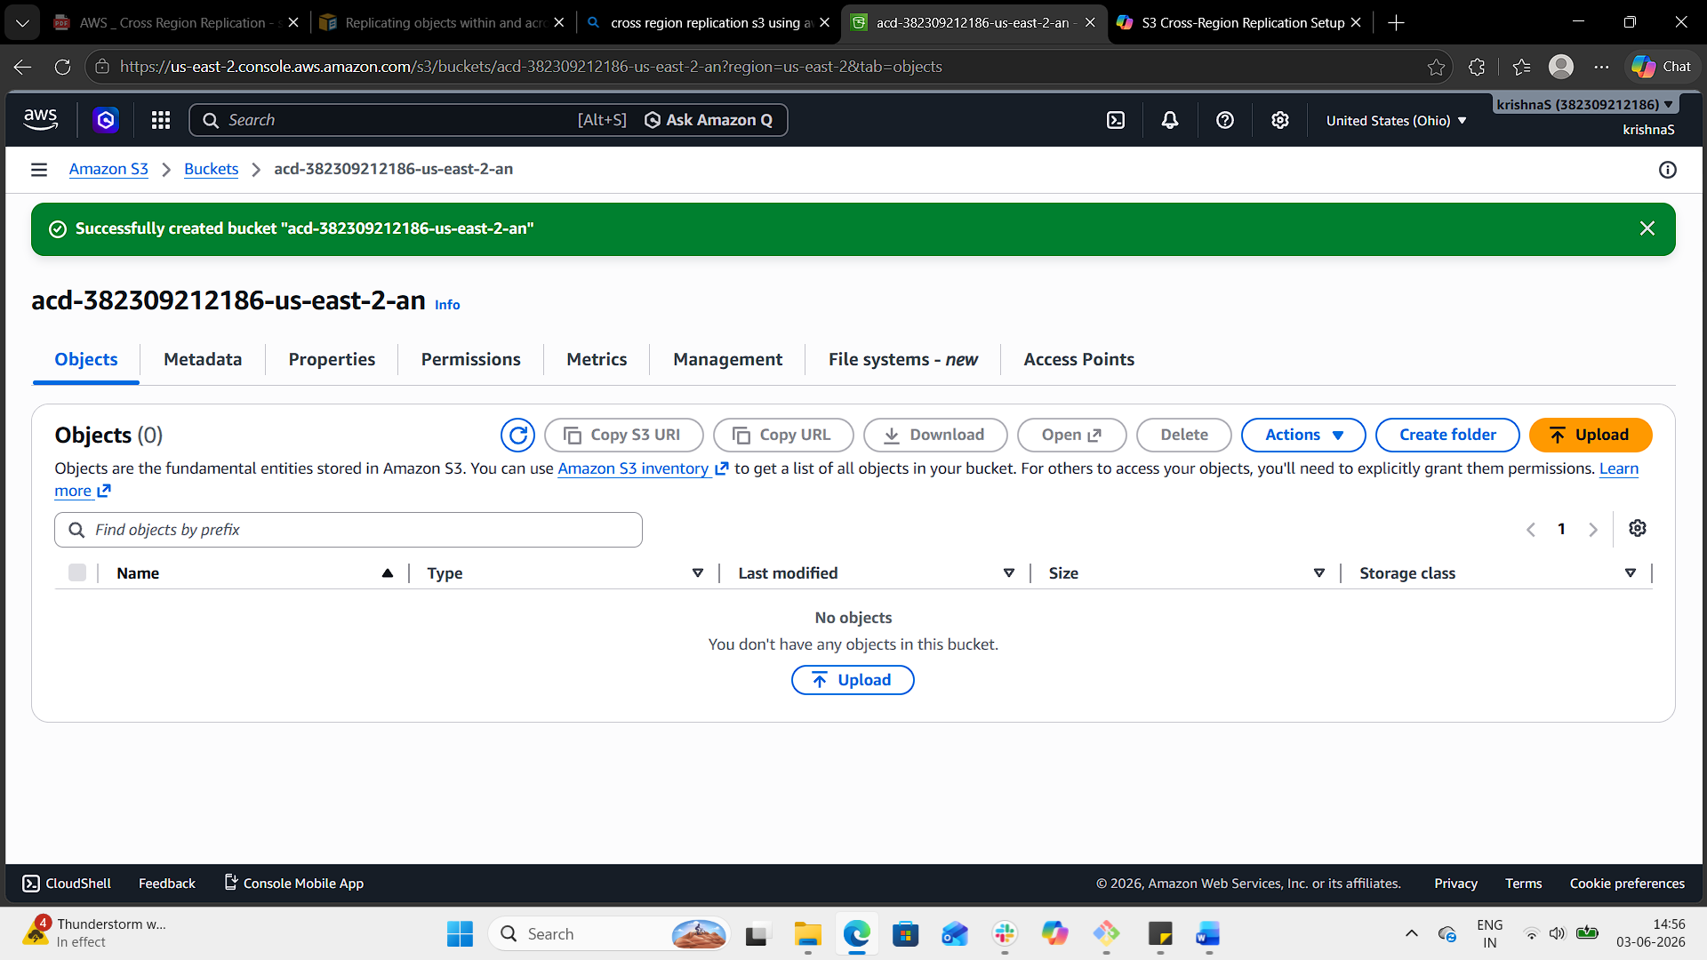

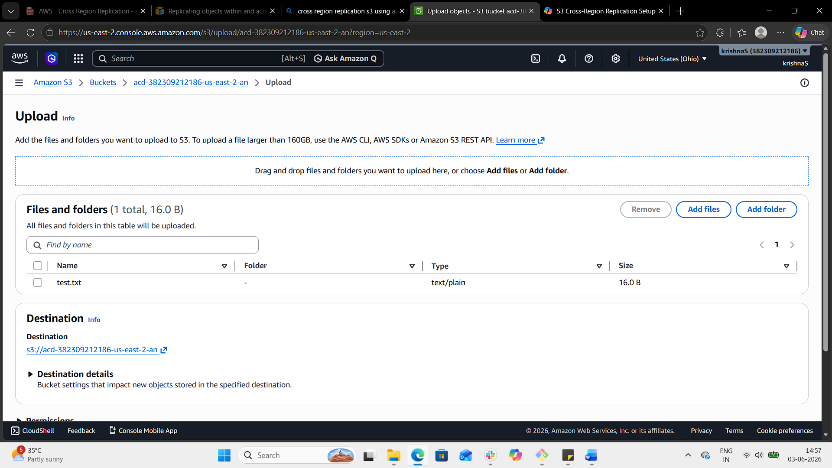

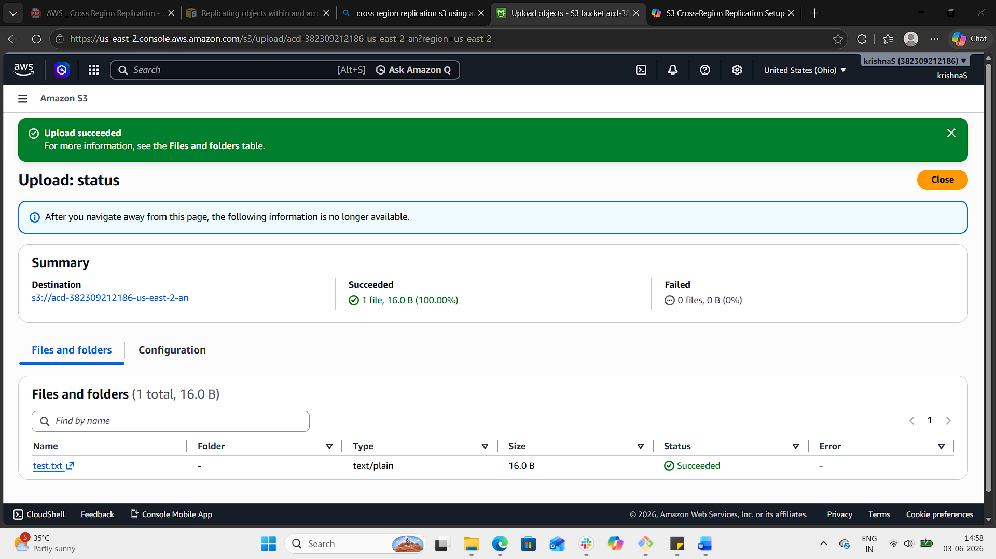

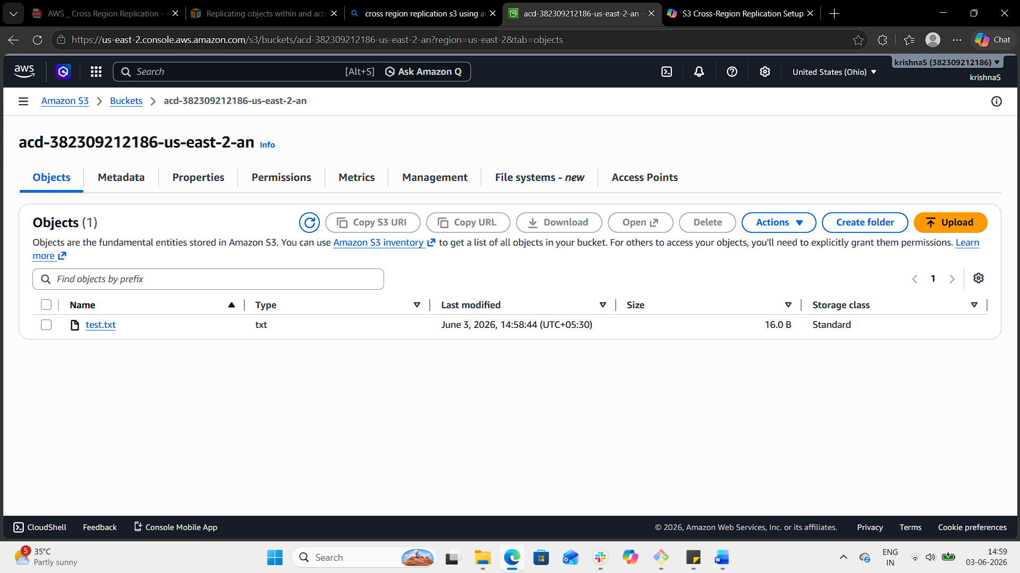

2. Deploy a static website in the S3 bucket.

Step 1: Create a Bucket
- Sign in to the AWS Management Console.
- Go to S3 → Create bucket.
- Enter a globally unique bucket name acd-382309212186-us-east-2-an.
- Choose a region us-east-2.
- Leave other settings default for now and click Create bucket.

Step 2: Upload Website Files
- Open your new bucket.
- Go to the Objects tab.
- Click Upload → Add files and select your index.html, error.html, CSS, JS, and image files.
- Click Upload.
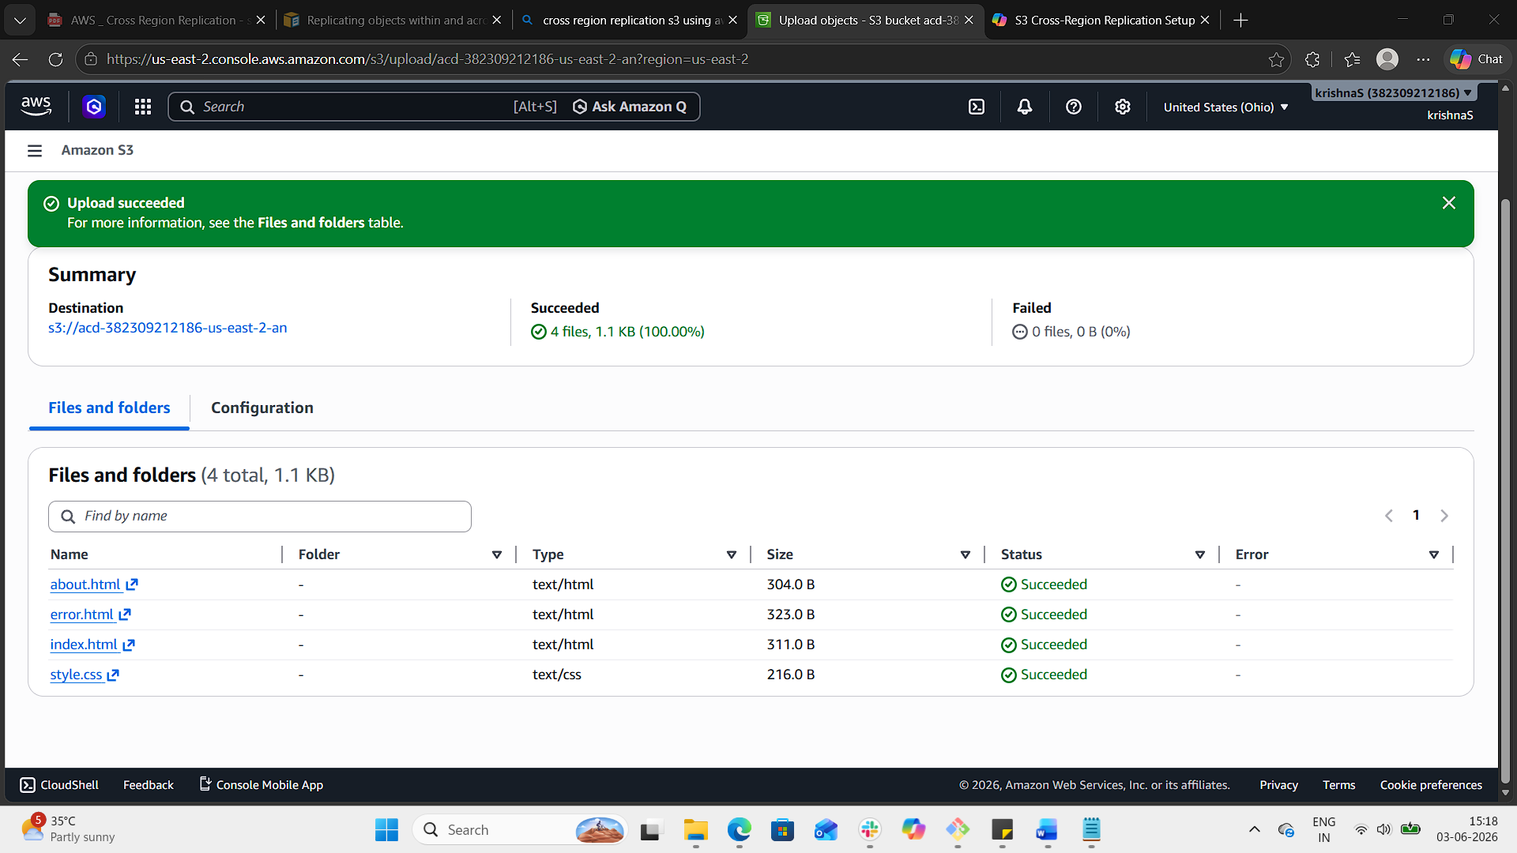

Step 3: Enable Static Website Hosting
- In the bucket, go to the Properties tab.
- Scroll down to Static website hosting.
- Click Edit → Enable.
- Enter:
  - Index document: index.html
  - Error document: error.html
- Save changes.
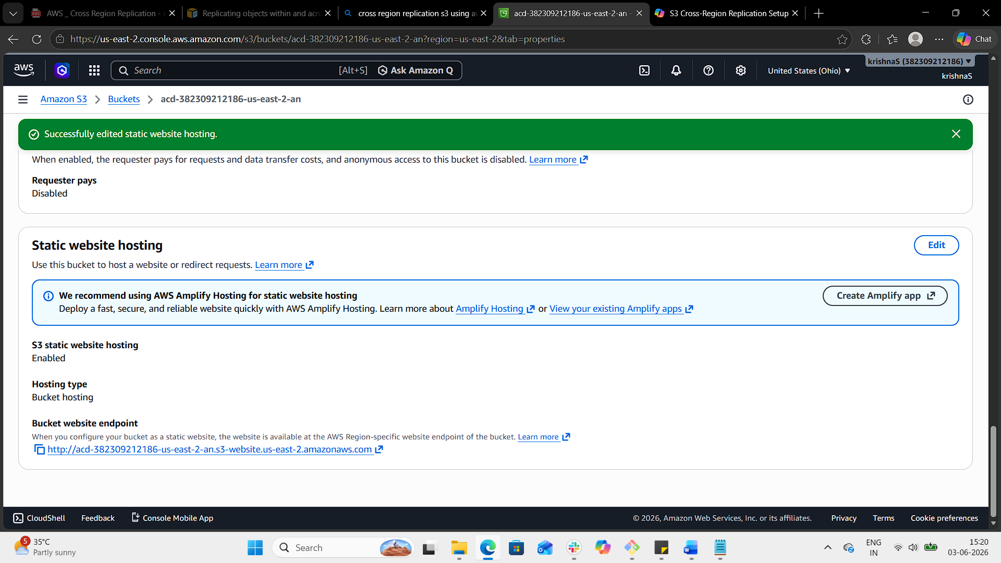

Step 4: Make Content Public
- Go to the Permissions tab.
- Under Bucket policy, add a policy that allows public read access:
json
{
"Version":"2012-10-17",
"Statement":[
{
"Sid":"PublicReadGetObject",
"Effect":"Allow",
"Principal":"*",
"Action":["s3:GetObject"],
"Resource":["arn:aws:s3:::my-static-site-12345/*"]
}
]
}
- Save the policy
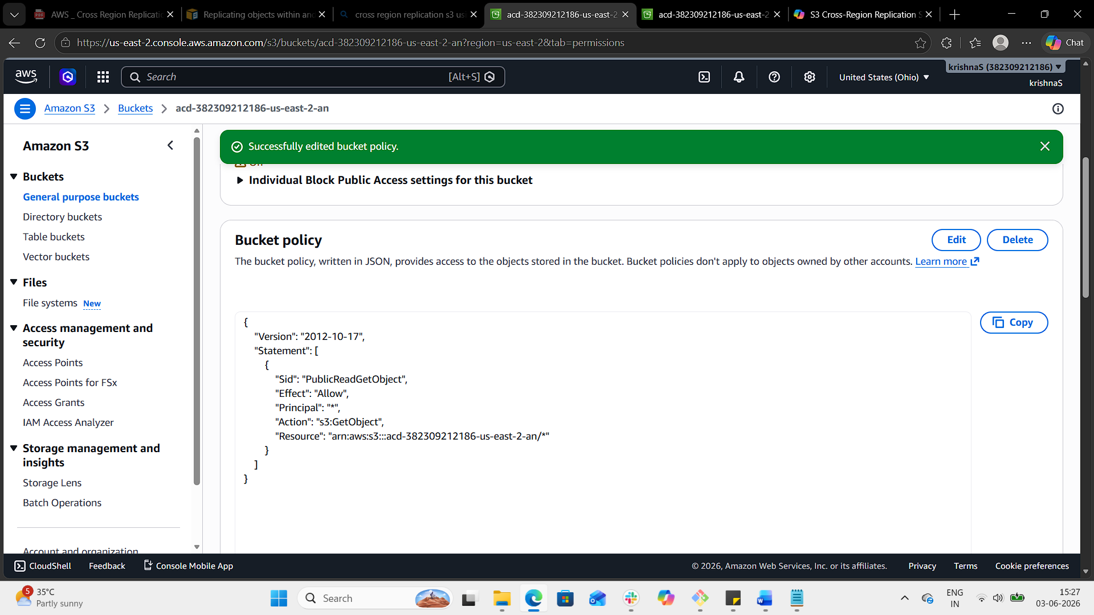

Step 5: Access Your Website
- After enabling hosting, AWS will show you a website endpoint URL, something like:
Code
http://acd-382309212186-us-east-2-an.s3-website.us-east-2.amazonaws.com
- Open this link in your browser to see your site live.
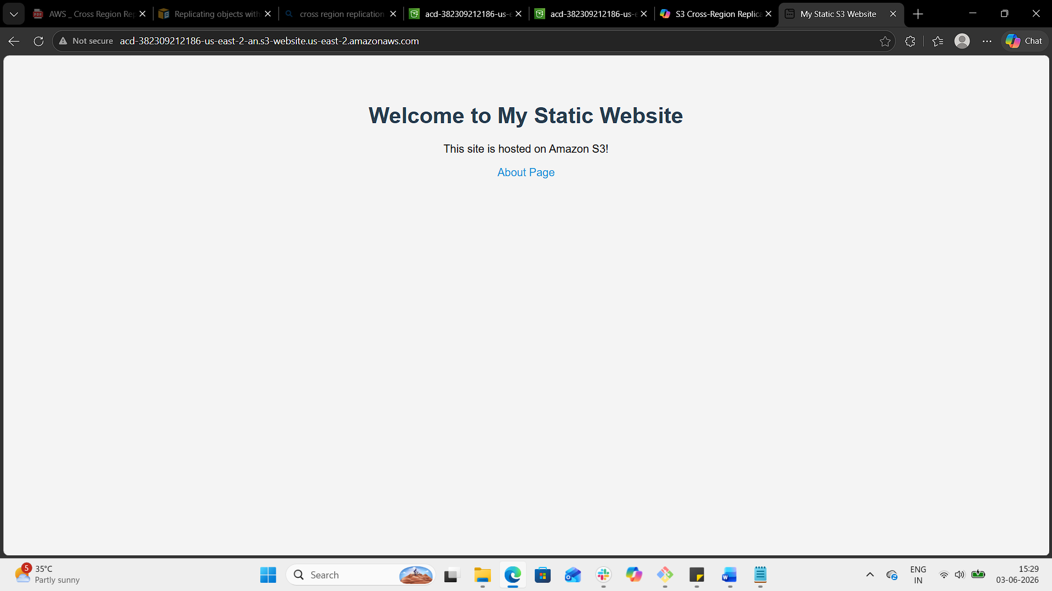
3. Enable cross-region replication on S3 buckets.
Using aws cli
Pre-requisites
- Two S3 buckets in different regions (e.g., source-bucket in us-east-1 and destination-bucket in ap-south-1).
- IAM role with s3:ReplicateObject, s3:ReplicateDelete, and s3:ReplicateTags permissions.
- Both buckets must have versioning enabled.

Step 1: Enable Versioning
bash
aws s3api put-bucket-versioning \
--bucket source-382309212186-us-east-1-an \
--versioning-configuration Status=Enabled

aws s3api put-bucket-versioning \
--bucket destination-382309212186-us-east-2-an \
--versioning-configuration Status=Enabled

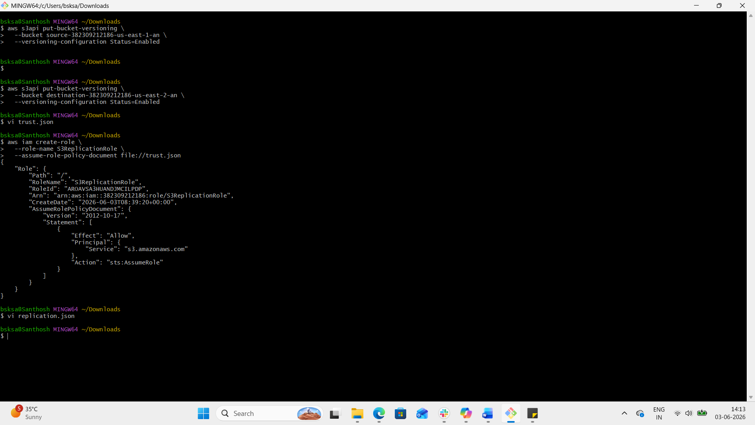

Step 2: Create IAM Role for Replication
Create a trust policy (trust.json) allowing S3 to assume the role:

json
{
"Version": "2012-10-17",
"Statement": [
{
"Effect": "Allow",
"Principal": { "Service": "s3.amazonaws.com" },
"Action": "sts:AssumeRole"
}
]
}

bash
aws iam create-role \
--role-name S3ReplicationRole \
--assume-role-policy-document file://trust.json

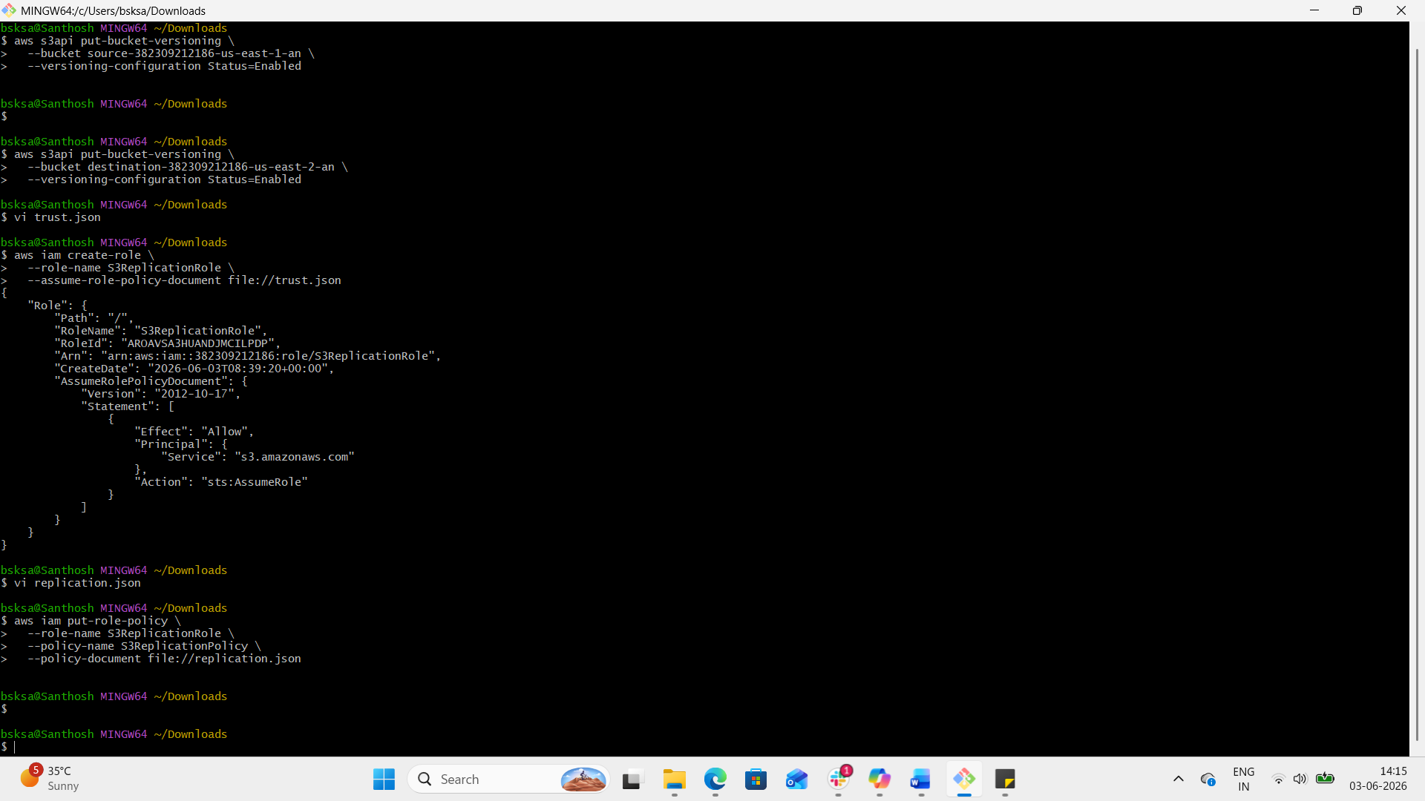

Attach replication policy (replication.json):

json
{
"Version": "2012-10-17",
"Statement": [
{
"Effect": "Allow",
"Action": [
"s3:GetObjectVersion",
"s3:GetObjectVersionAcl",
"s3:GetObjectVersionTagging"
],
"Resource": "arn:aws:s3:::source-382309212186-us-east-1-an/*"
},
{
"Effect": "Allow",
"Action": [
"s3:ReplicateObject",
"s3:ReplicateDelete",
"s3:ReplicateTags"
],
"Resource": "arn:aws:s3:::destination-382309212186-us-east-2-an /*"
}
]
}
bash
aws iam put-role-policy \
--role-name S3ReplicationRole \
--policy-name S3ReplicationPolicy \
--policy-document file://replication.json

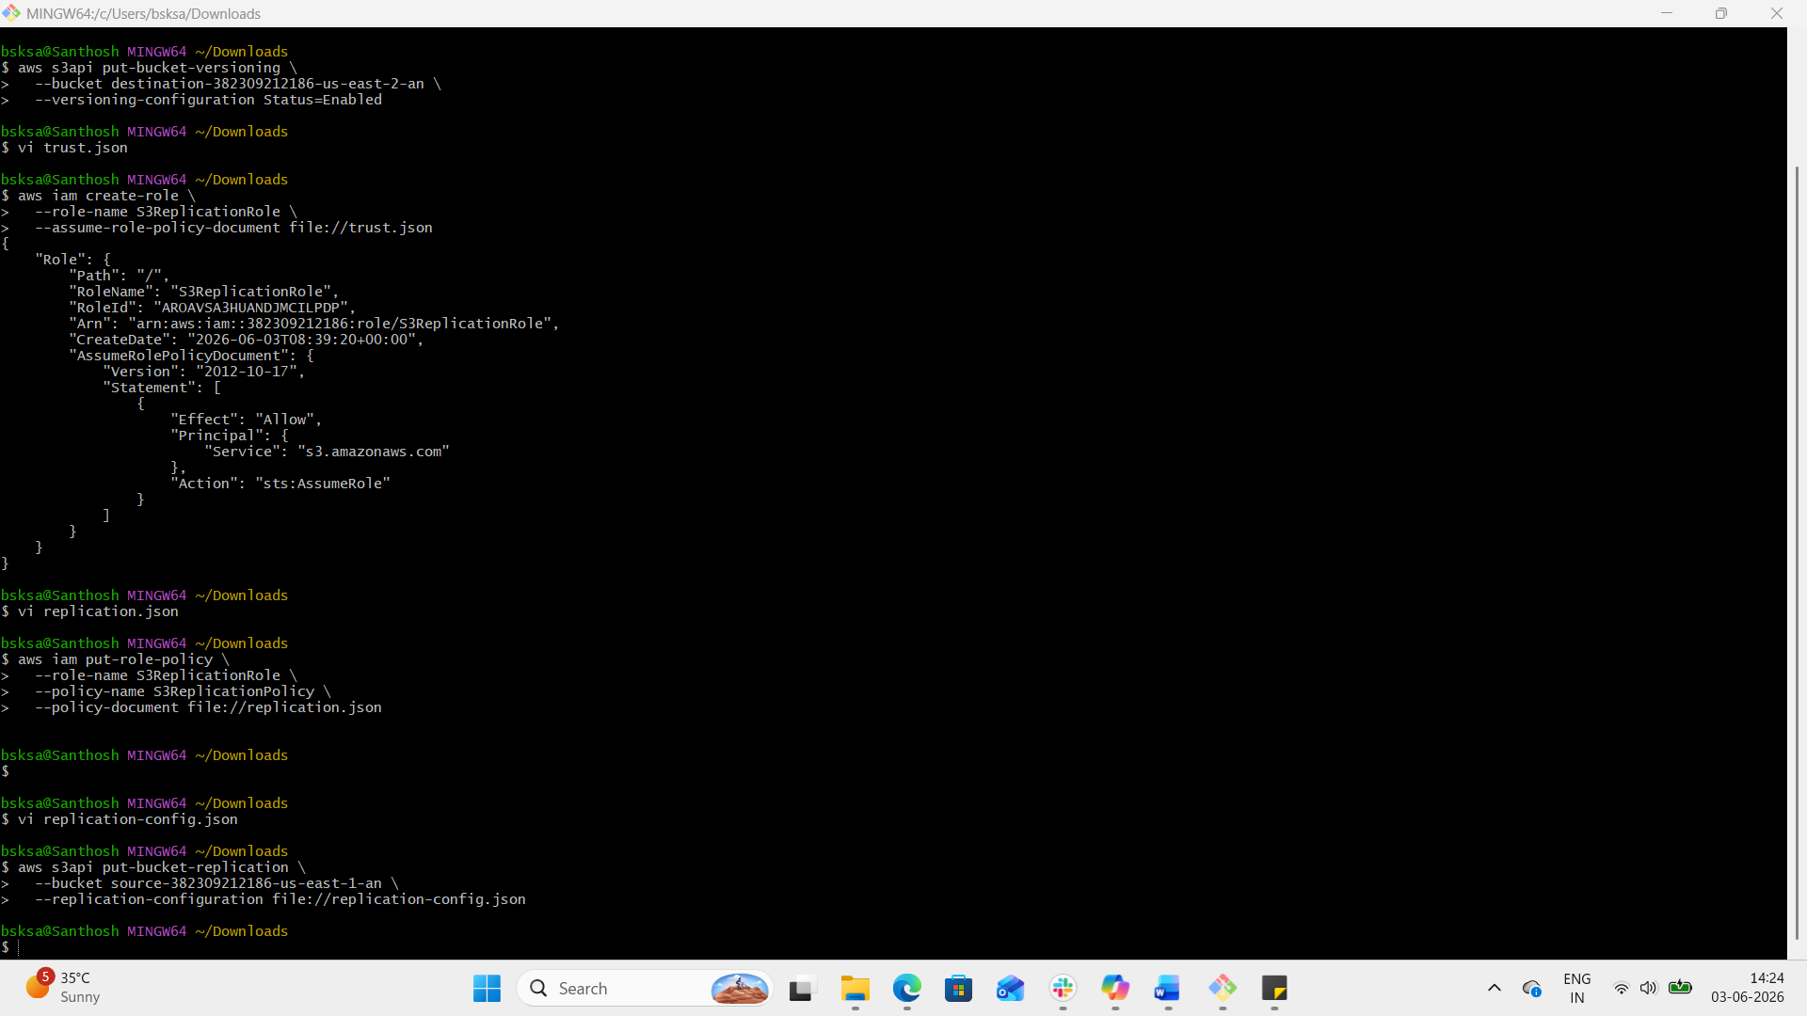

Step 3: Configure Replication Rule
Create a replication configuration file (replication-config.json):

json
{
"Role": "arn:aws:iam::382309212186:role/S3ReplicationRole",
"Rules": [
{
"ID": "CRRRule",
"Status": "Enabled",
"Priority": 1,
"DeleteMarkerReplication": { "Status": "Disabled" },
"Filter": { "Prefix": "" },
"Destination": {
"Bucket": "arn:aws:s3:::destination-382309212186-us-east-2-an ",
"StorageClass": "STANDARD"
}
}
]
}
Apply it:

bash
aws s3api put-bucket-replication \
--bucket source-bucket \
--replication-configuration file://replication-config.json

Verification
Upload a test object to the source bucket:

bash
aws s3 cp test.txt s3://source-bucket/
Check if it appears in the destination bucket:

bash
aws s3 ls s3://source-382309212186-us-east-1-an/

Without using aws cli

Step 1: Prerequisites
- Two S3 buckets in different regions (source-382309212186-us-east-1-an in us-east-1 and destination-382309212186-us-east-2-an in us-east-2).
- Both buckets must have versioning enabled.
- An IAM role with replication permissions (s3:GetObjectVersion, s3:ReplicateObject, etc.).
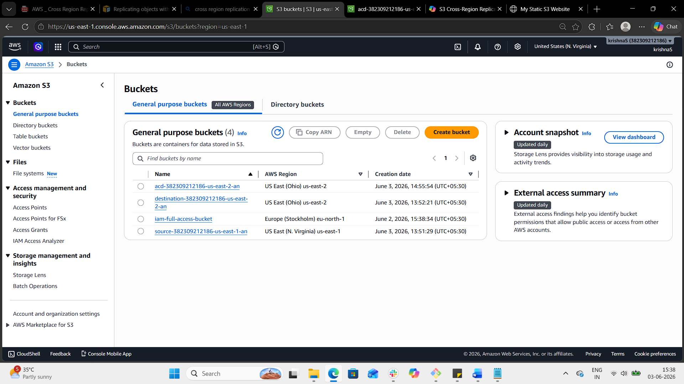

Step 2: Enable Versioning
- Open the source bucket in the S3 console.
- Go to Properties → Bucket Versioning → Edit → Enable.
- Do the same for the destination bucket.

Step 3: Configure Replication
- In the source bucket, go to Management → Replication → Add rule.
- Choose Entire bucket or specify a prefix/filter.
- Select Destination bucket (must be in another region).
- Choose IAM role:
  - Either let S3 create a new role automatically.
  - Or select an existing role with replication permissions.
- Configure options:
  - Storage class for replicated objects (e.g., STANDARD, Glacier).
  - Replication metrics and notifications (optional).
  - Delete marker replication (optional).
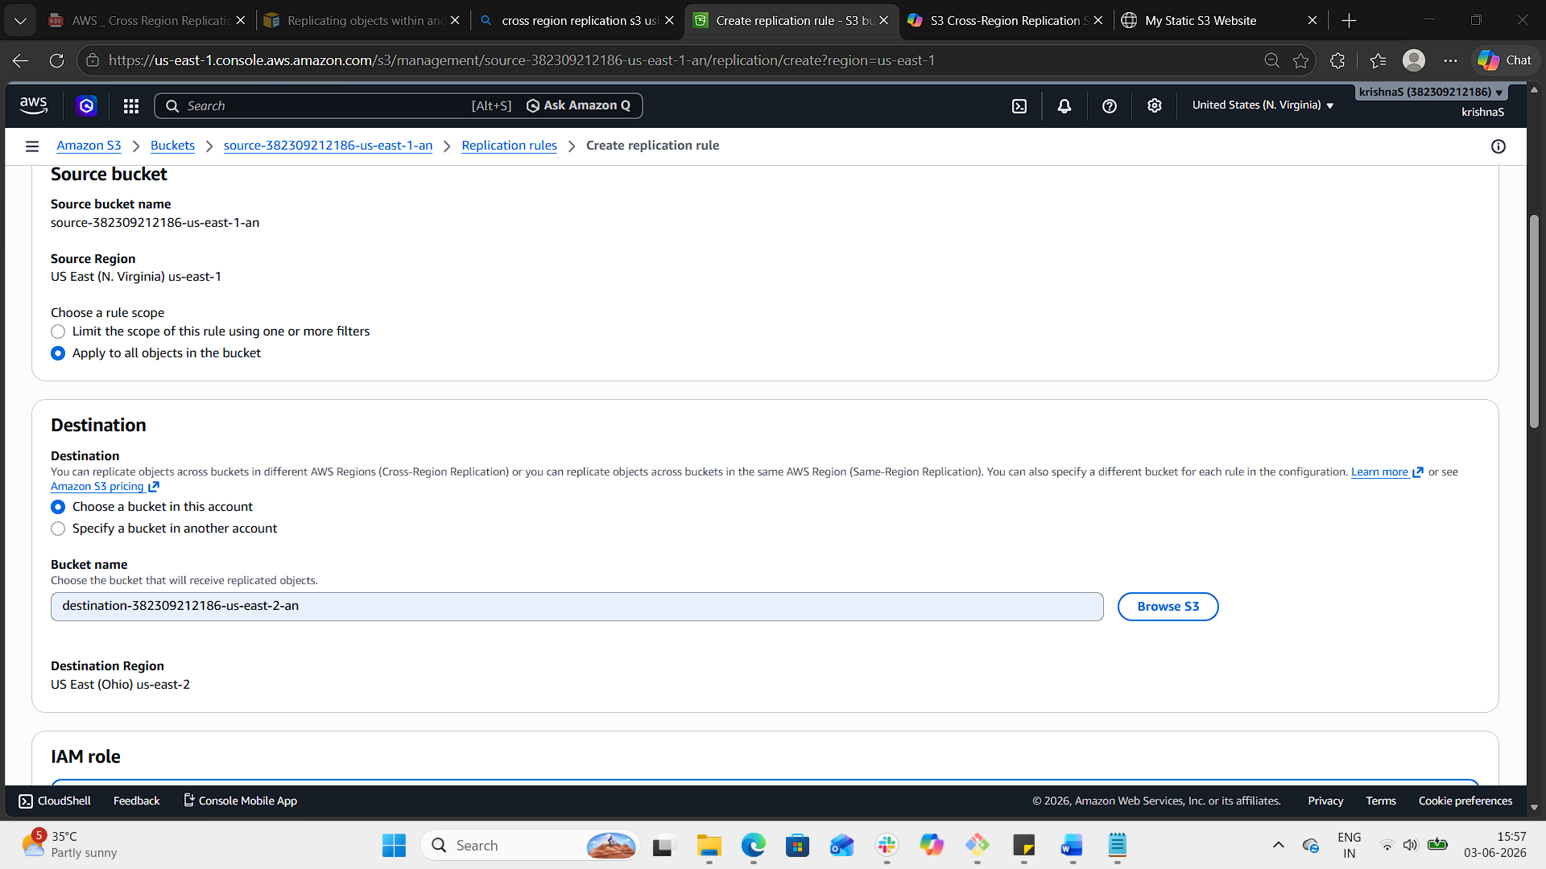
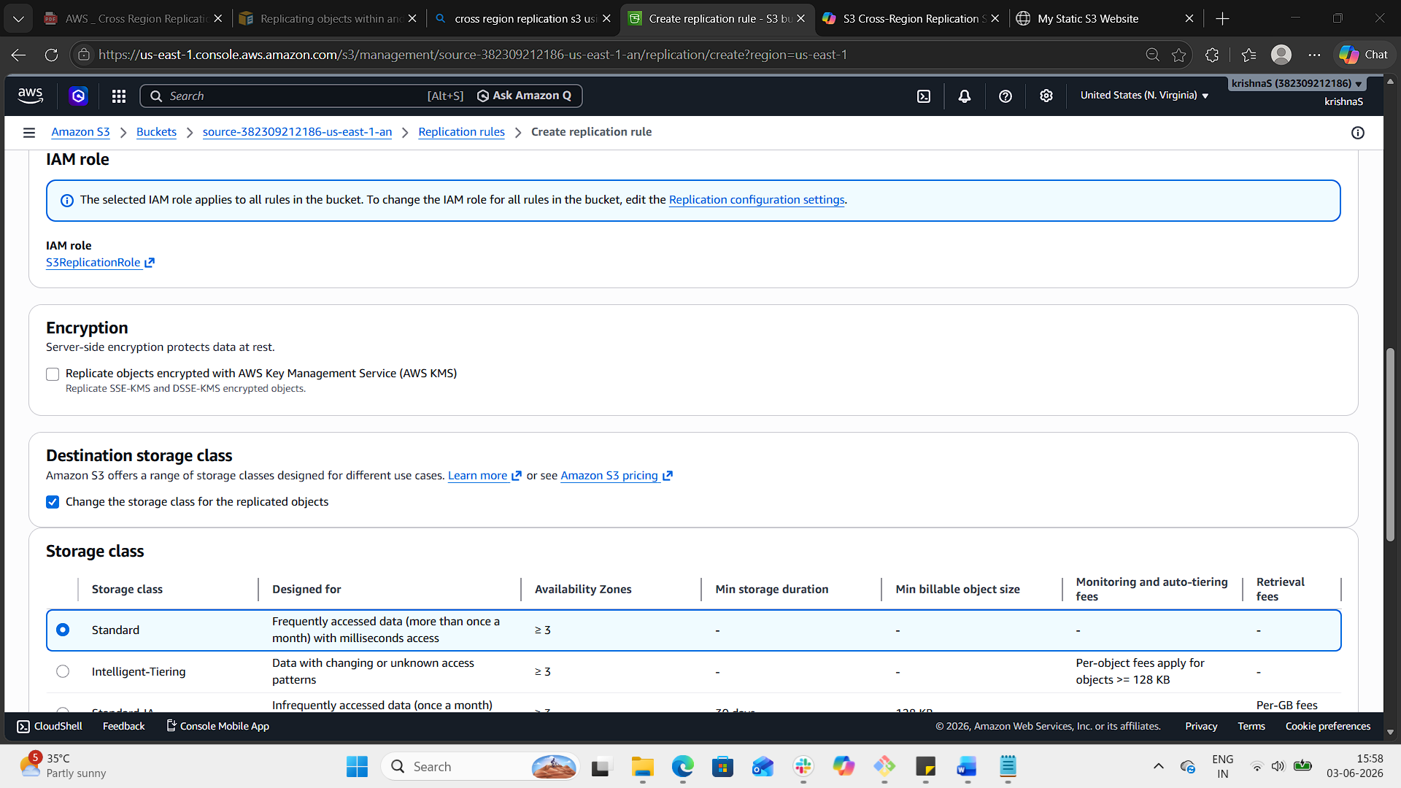
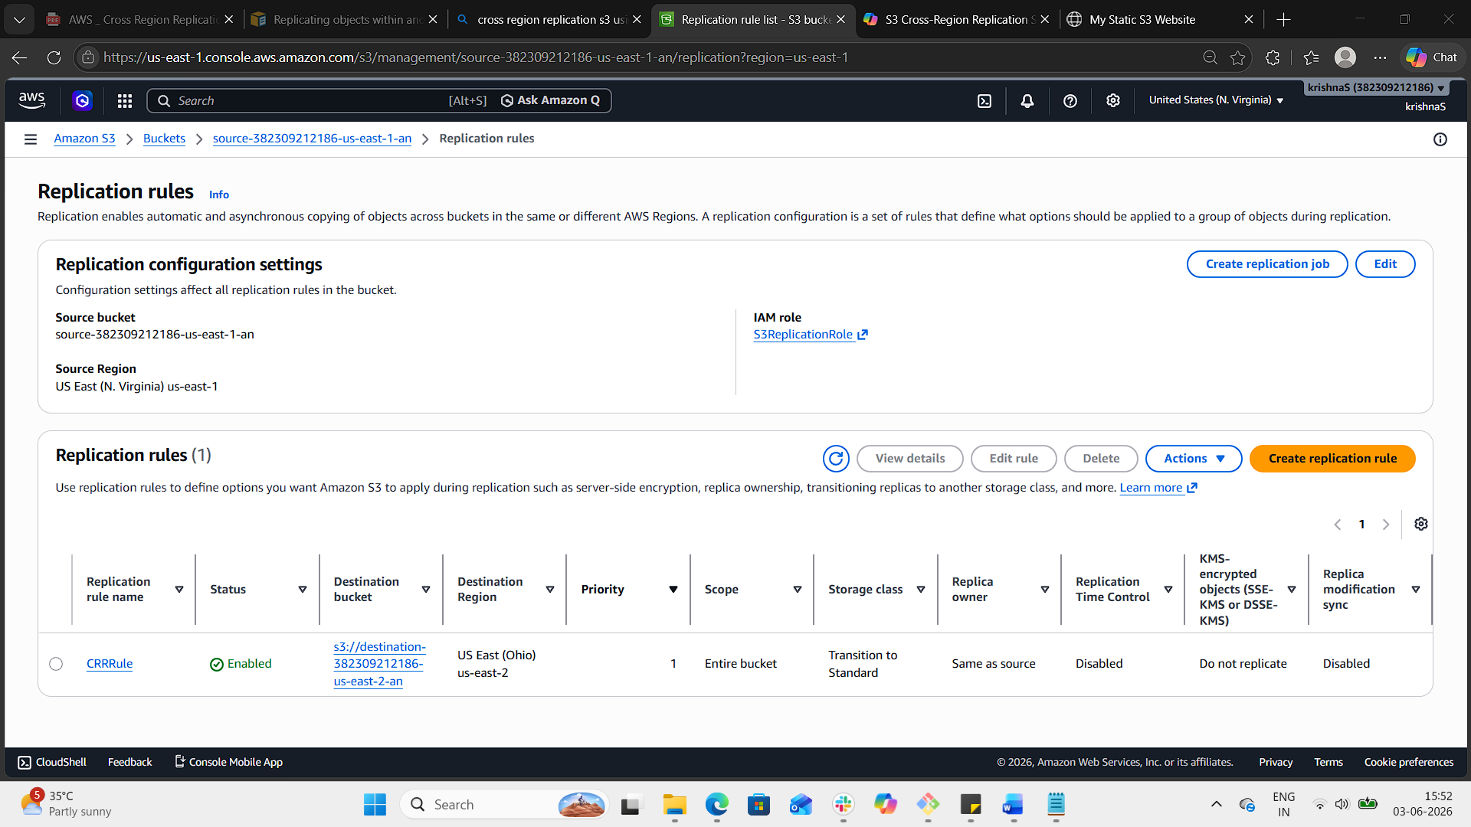
Step 4: Save Rule
- Click Save.
- The replication rule is now active. New objects uploaded to the source bucket will be automatically replicated to the destination bucket.

Step 5: Verification
- Upload a test file to the source bucket.
- Check the destination bucket in the other region.
- The file should appear there within minutes.
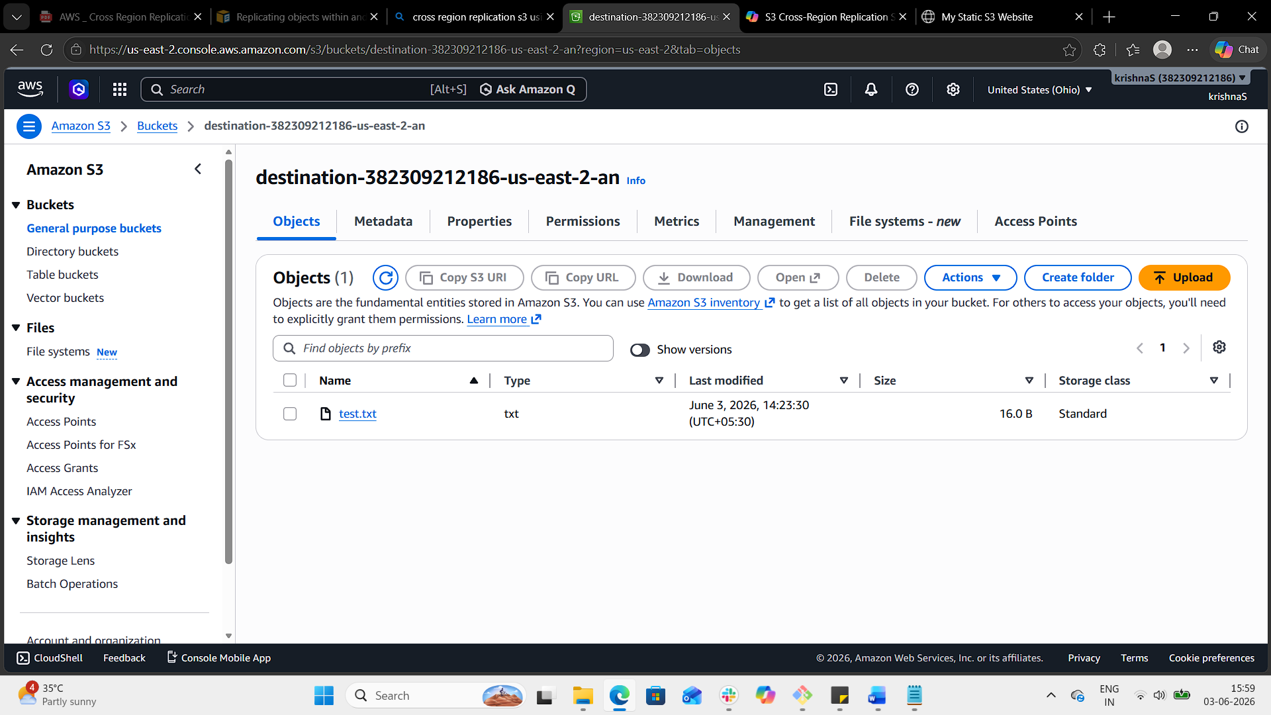

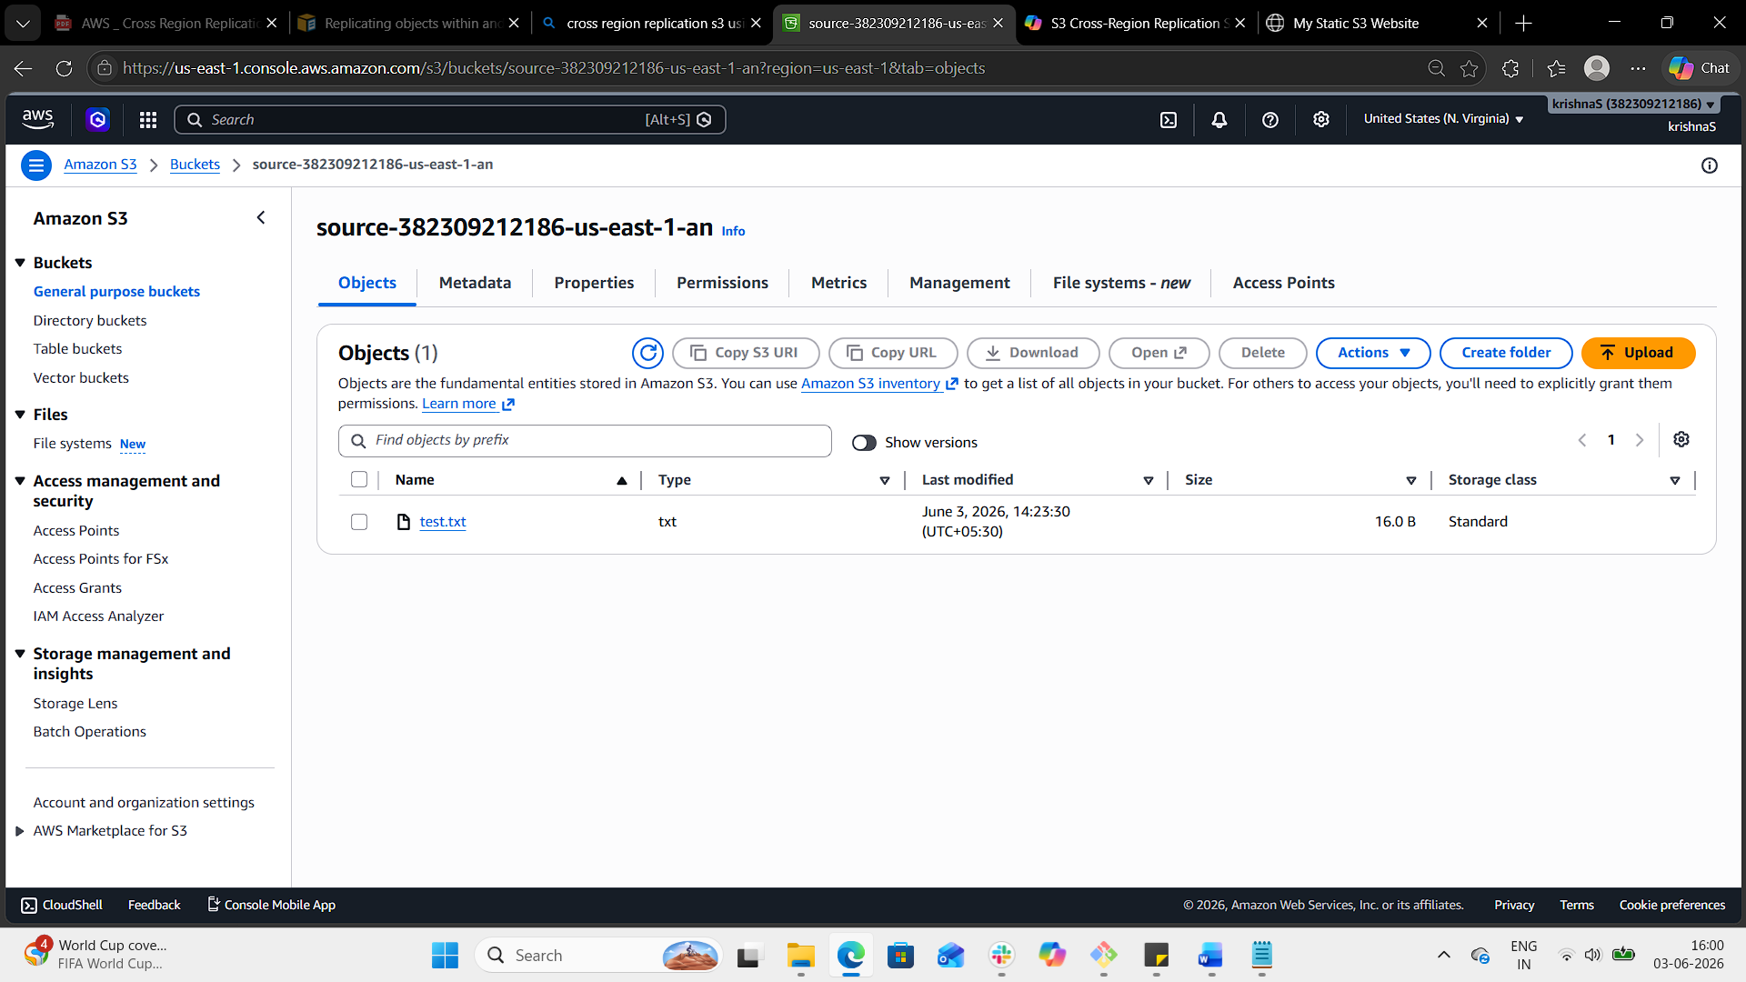

4. Configure a bucket policy so only the Admin user can see the objects of the S3 bucket.

Steps in AWS Console
- Go to the S3 Console → select your bucket.
- Navigate to Permissions → Bucket Policy → Edit.
- Paste the JSON above (with your values).
- Save changes.
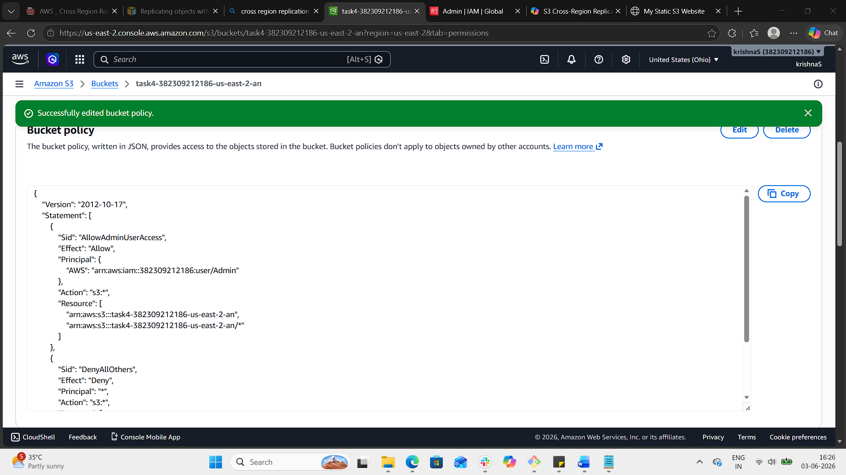
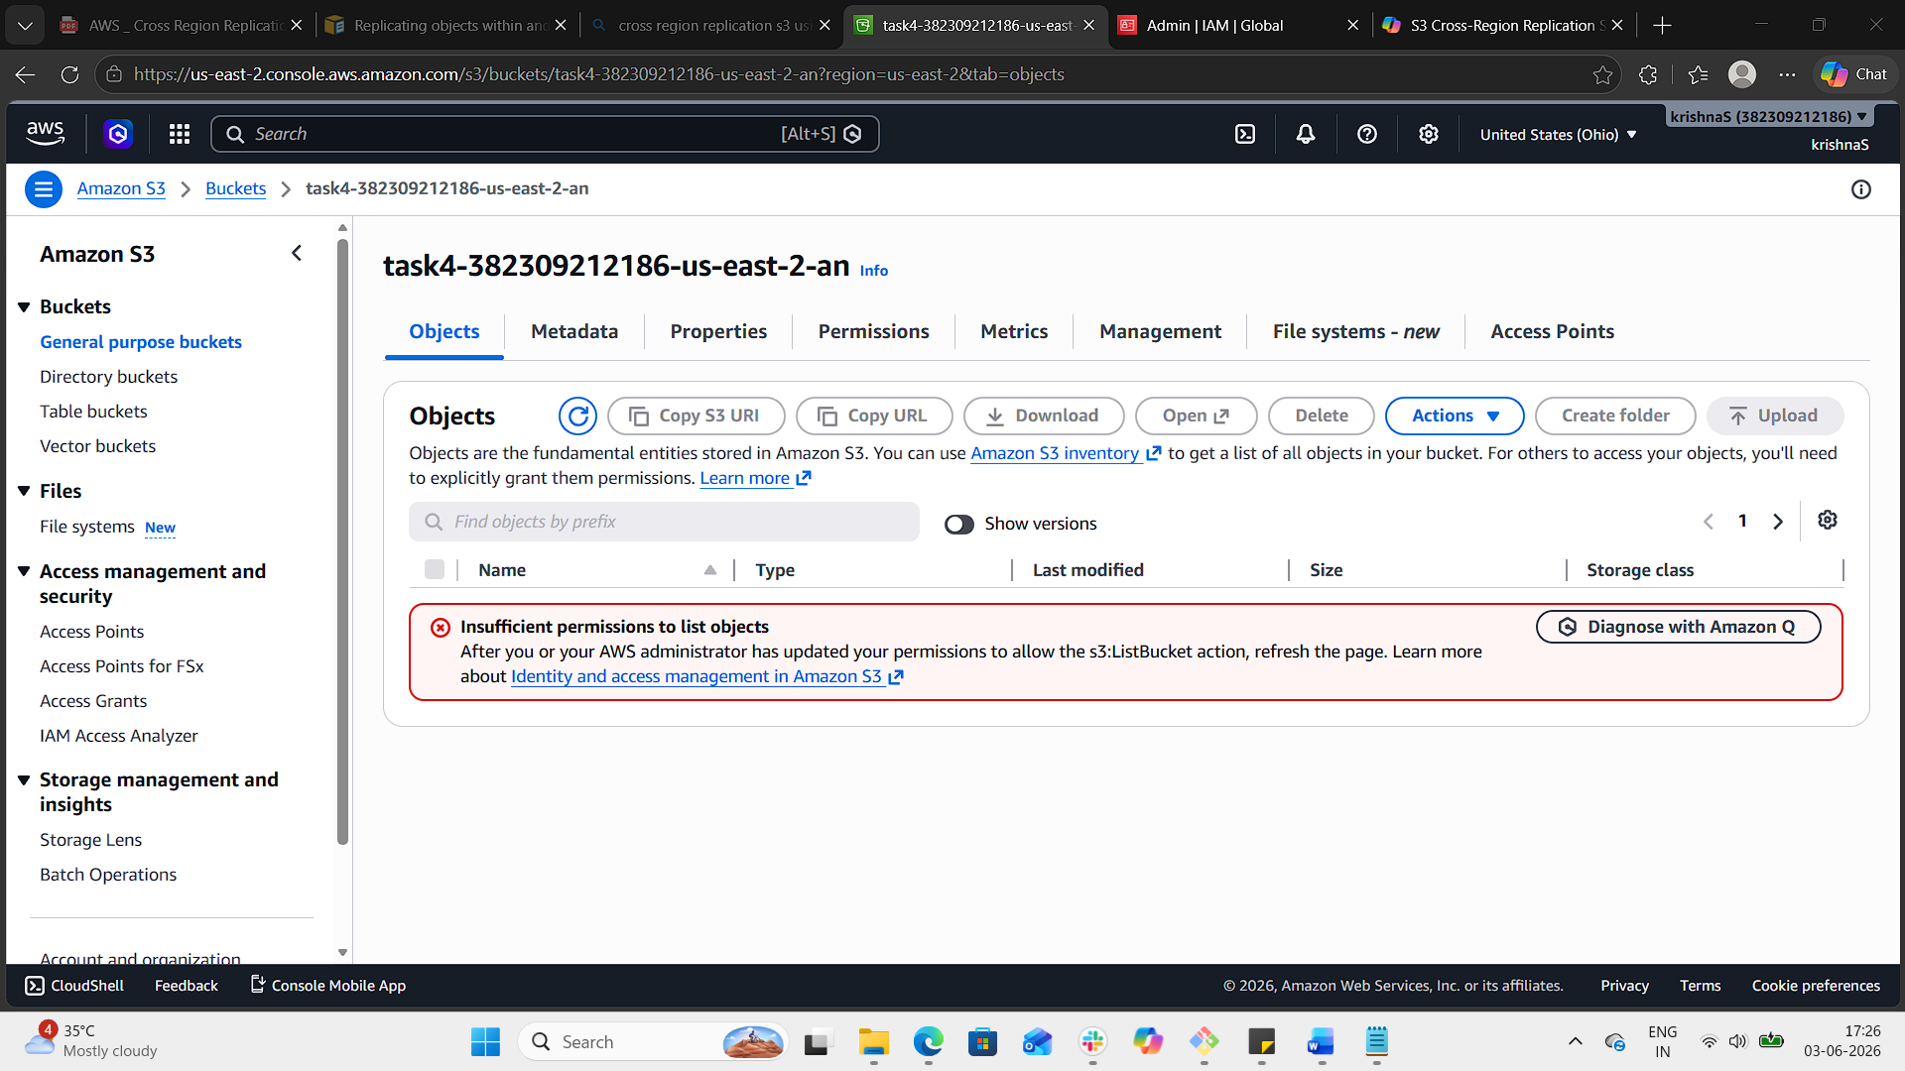

Result
- The Admin IAM user will have full access to the bucket and its objects.
- All other users, roles, or anonymous requests will be denied.

5. Set up lifecycle policies to automatically transition or delete objects based on specific criteria.

Step 1: Open Your Bucket
- Go to the S3 Console → select your bucket (you already have the S3 buckets | S3 | us-east-2 tab open).
- Click on the bucket name.
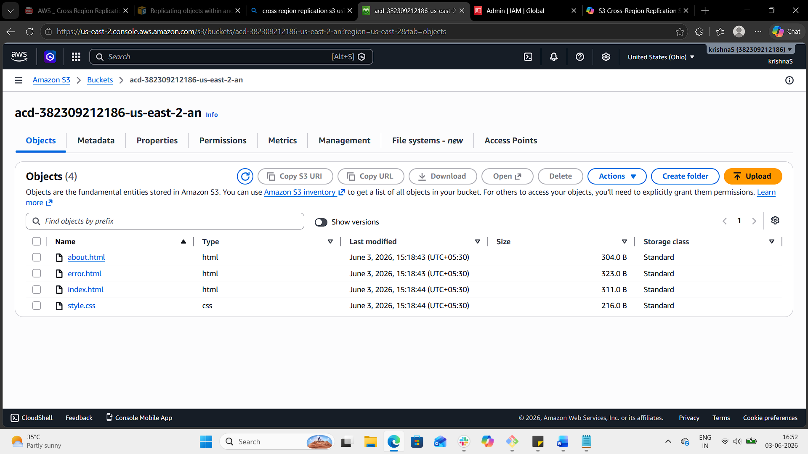

Step 2: Navigate to Lifecycle Rules
- In the bucket, go to the Management tab.
- Scroll down to Lifecycle rules.
- Click Create lifecycle rule.
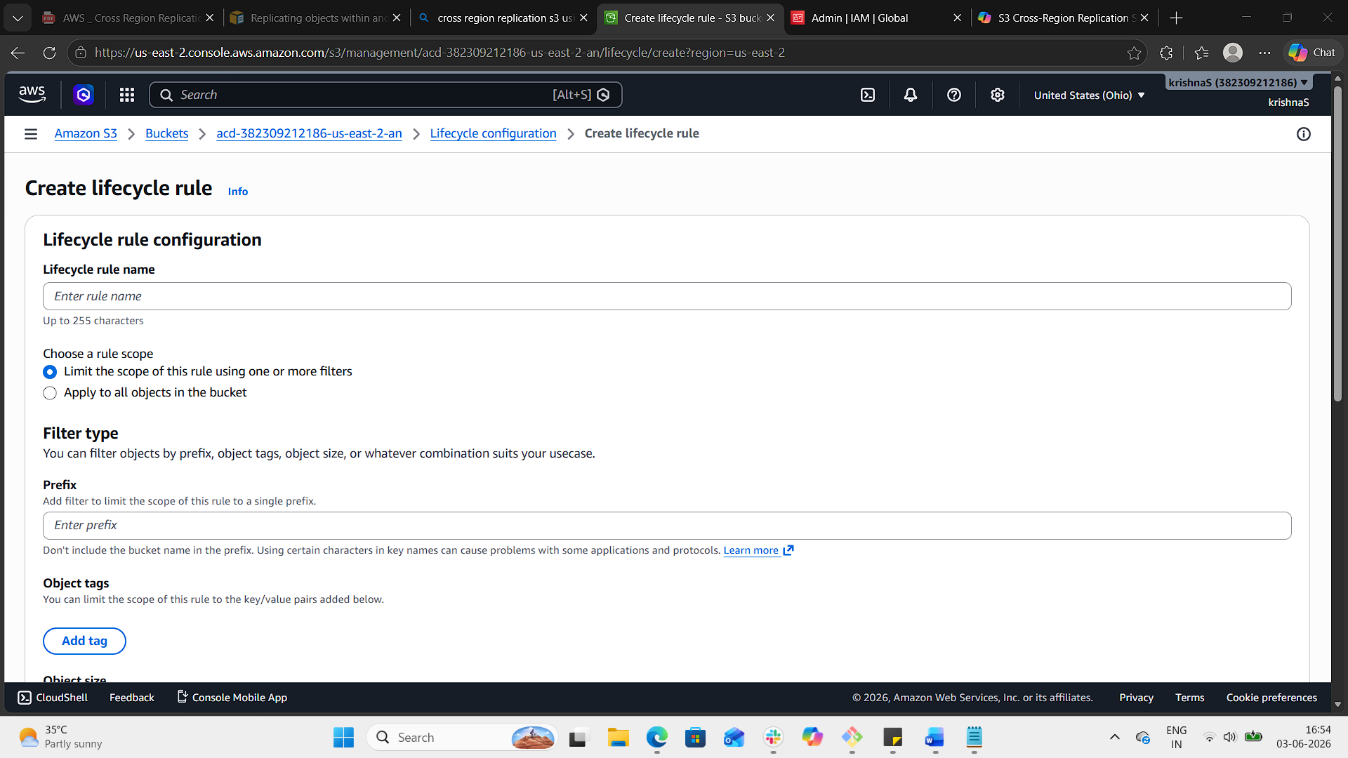

Step 3: Define Rule Criteria
- Rule name: e.g., TransitionToGlacierAndDelete.
- Scope: Apply to the entire bucket or filter by prefix (folder) or object tags.
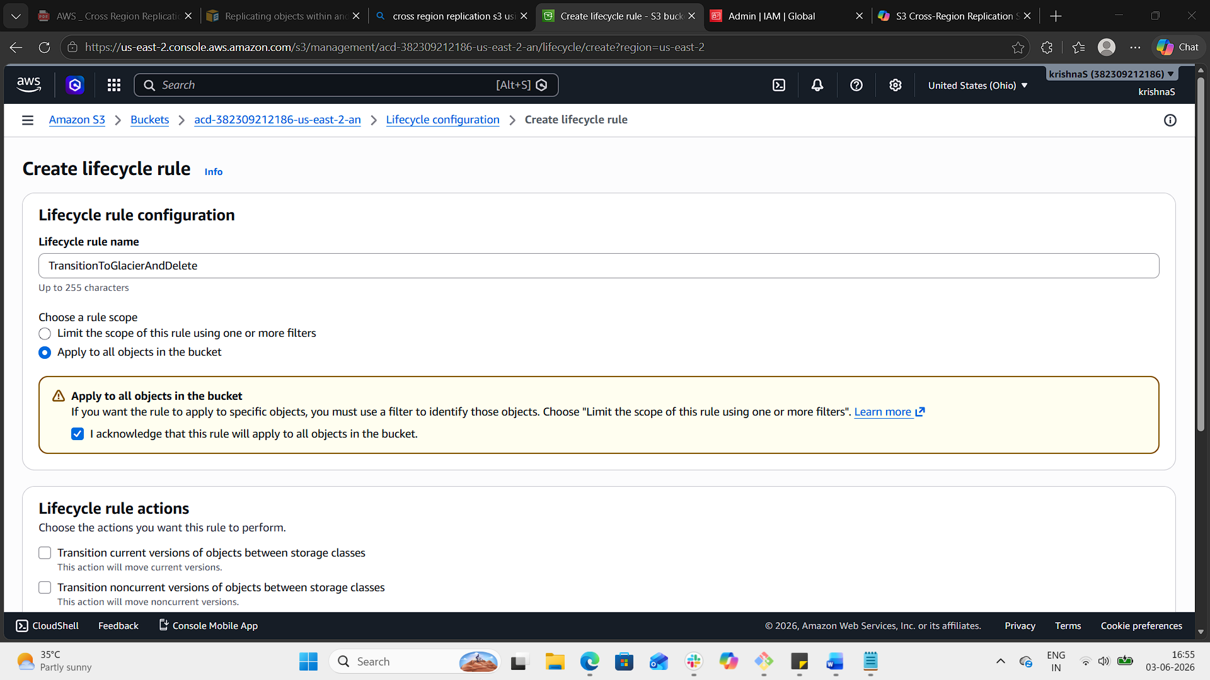

Step 4: Add Actions
You can add multiple actions in one rule:
- Transition to another storage class Example: Move objects to S3 Glacier after 30 days.
  - Select Transition current versions of objects.
  - Choose Glacier Flexible Retrieval.
  - Set Days after creation = 30.
- Expire/Delete objects Example: Permanently delete objects after 365 days.
  - Select Expire current versions of objects.
  - Set Days after creation = 365.
- Clean up incomplete multipart uploads Example: Abort uploads not finished within 7 days.
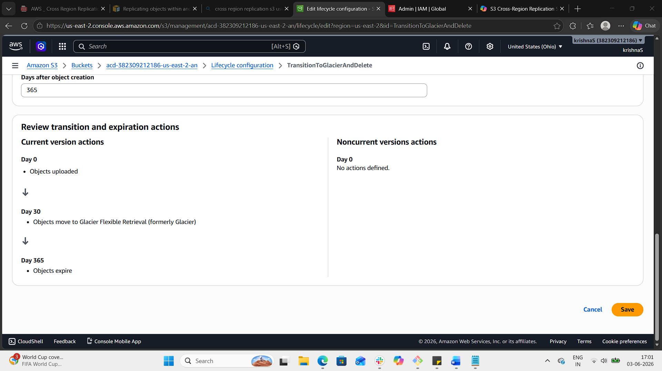

Step 5: Save Rule
- Review your settings.
- Click Create rule.
- The lifecycle policy is now active.
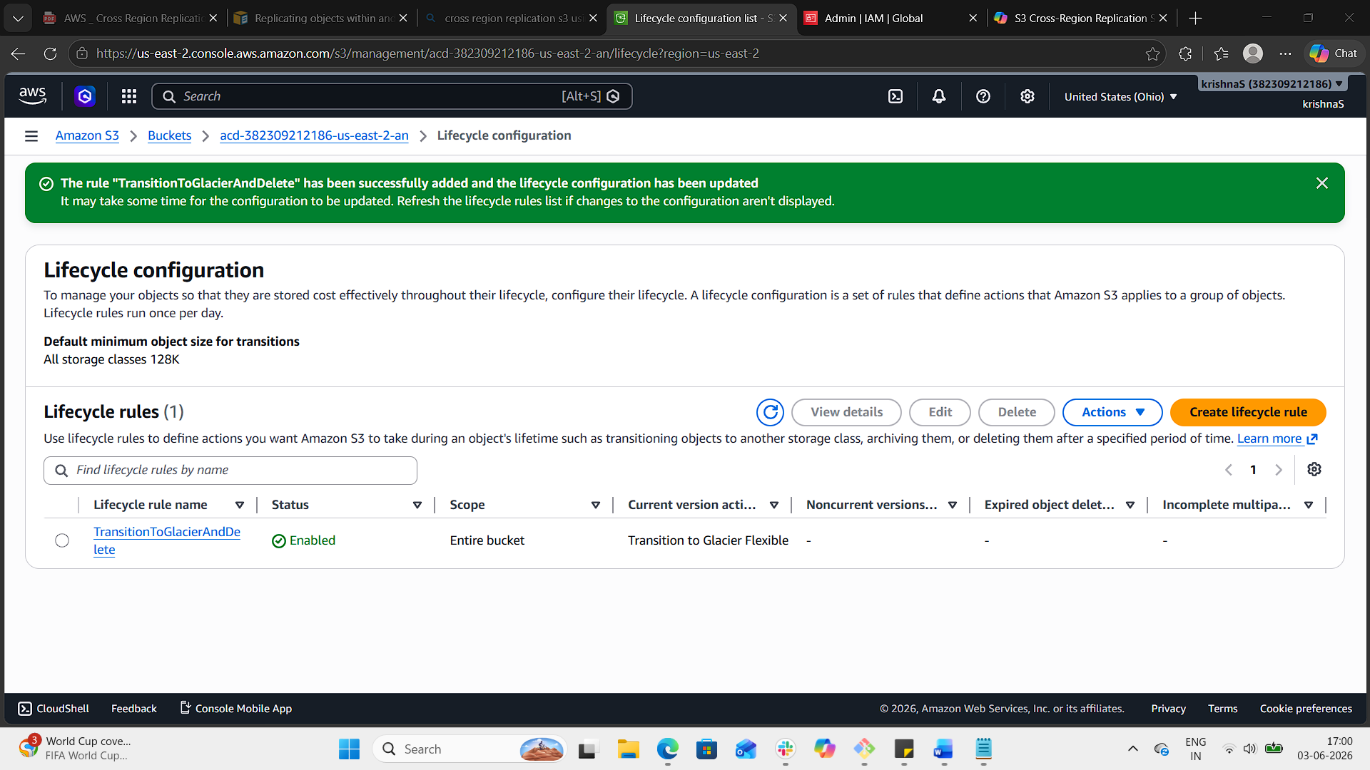

Example Use Case
- Transition logs to Glacier after 30 days.
- Delete them after 1 year.
- This reduces storage costs while keeping data available for compliance
6. Push some objects to S3 using the AWS CLI.

Open git bash.
aws - -version to check if aws cli is available
aws configure
enter:
access key :
secret key :
location : us-east-1
file format : json

To upload trust.json file to destination bucket
aws s3 cp C:/Users/bsksa/Downloads/trust.json s3://destination-382309212186-us-east-2-an

To check the file objects in the bucket
aws s3 ls s3://destination-382309212186-us-east-2-an
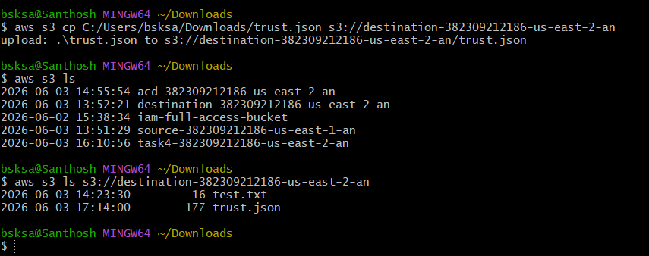

7. Write a Bash script to create an S3 bucket.

#!/bin/bash
# Script to create an S3 bucket
# Usage: ./create_s3_bucket.sh bucket-name region
BUCKET_NAME=$1
REGION=$2
if [ -z "$BUCKET_NAME" ] || [ -z "$REGION" ]; then
echo "Usage: $0 <bucket-name> <region>"
exit 1
fi
echo "Creating S3 bucket: $BUCKET_NAME in region: $REGION"
# Create the bucket
aws s3api create-bucket \
--bucket "$BUCKET_NAME" \
--region "$REGION" \
--create-bucket-configuration LocationConstraint="$REGION"
# Enable versioning (optional, useful for replication/backups)
aws s3api put-bucket-versioning \
--bucket "$BUCKET_NAME" \
--versioning-configuration Status=Enabled
echo "Bucket $BUCKET_NAME created successfully with versioning enabled."
- Save the script as create_s3_bucket.bash.
- Make it executable:
bash
chmod +x create_s3_bucket.bash
- Run it with your bucket name and region:
bash
./create_s3_bucket.sh my-demo-bucket-9966881131 us-east-2

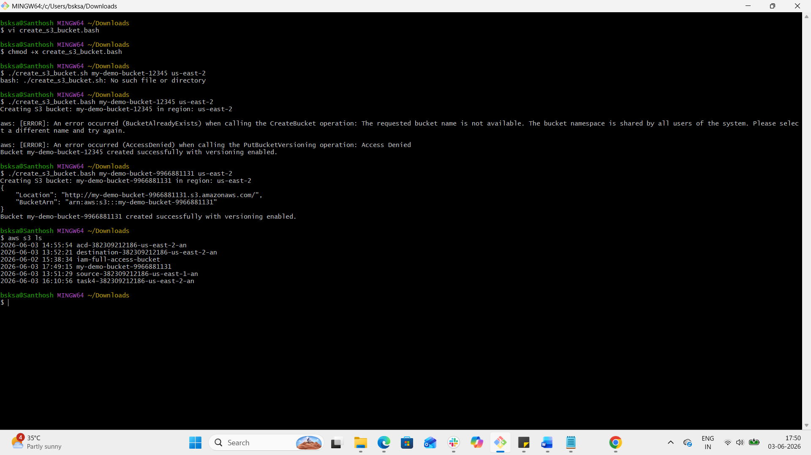

8. Upload a 1 GB file to S3 using the CLI.

Step 1: Upload the File
bash
aws s3 cp ./1GB.bin s3://my-demo-bucket-9966881131/
- ./1GB.bin → path to your 1 GB file
- my-demo-bucket-9966881131 → replace with your bucket name
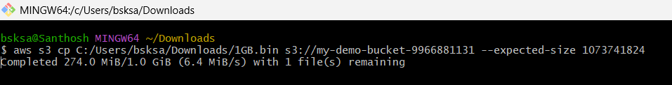
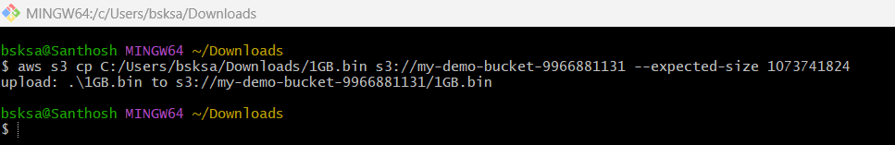

Step 2: Verify Upload
bash

aws s3 ls s3://my-demo-bucket-9966881131/

